13.57: a)
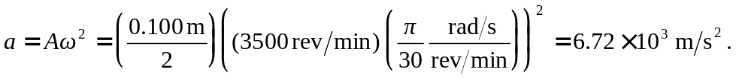
b) d) At the midpoint of the stroke, cos(t)=0
and so so
e) If the frequency doubles, the acceleration and hence the needed force will quadruple (12.1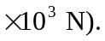The maximum speed increases by a factor of 2 since 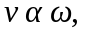 so the speed will be 36.7 m/s. Because the kinetic energy depends on the square of the velocity, the kinetic energy will increase by a factor of four (302 J). But, because the time to reach the midpoint is halved, due to the doubled velocity, the power increases by a factor of eight (141 kW).

